**2CS503 Design and Analysis of Algorithm**

**BTech Sem V (CSE)**

**Year: 2021-22 (ODD)**

**Tutorial No 7 Assignment Problem**

Q.1 Which of the following standard algorithms is not a Greedy algorithm?

1. Dijkstra's shortest path algorithm
2. Prim's algorithm
3. Kruskal algorithm
4. Huffman Coding
5. Bellmen Ford Shortest path algorithm

Q.2 (a)Consider Knapsack capacity 𝑊=50, 𝑤 = (10, 20, 40) and 𝑣 = (60, 80,100) find the maximum profit using greedy approach.

(b)Consider Knapsack capacity 𝑊 = 10, 𝑤=(4, 8, 2, 6, 1) and 𝑣 = (12, 32, 40, 30, 50). Find the maximum profit using greedy approach.

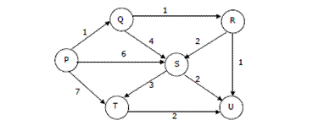Q.3 Suppose we run Dijkstra’s single source shortest-path algorithm on the following edge weighted directed graph with vertex P as the source. In what order do the nodes get included into the set of vertices for which the shortest path distances are finalized?

1. P, Q, R, S, T, U
2. P, Q, R, U, S, T
3. P, Q, R, U, T, S
4. P, Q, T, R, U, S

Q.4 Which of the following is true about Kruskal and Prim MST algorithms? Assume that Prim is implemented for adjacency list representation using Binary Heap and Kruskal is implemented using union by rank.

1. Worst case time complexity of both algorithms is same
2. Worst case time complexity of Kruskal is better than Prim
3. Worst case time complexity of Prim is better than Kruskal

Q.5 Suppose the letters a, b, c, d, e, f have probabilities 1/2, 1/4, 1/8, 1/16, 1/32, 1/32 respectively. What is the average length of the Huffmans codes and code for the letter a, b, c, d, e, f?

1. 3 and 11, 10, 011, 010, 001, 000
2. 2.1875 and 11, 10, 01, 001, 0001, 0000
3. 2.25 and 110, 100, 010, 000, 001, 111
4. 1.9375 and 0, 10, 110, 1110, 11110, 11111

Q.6 Consider the undirected graph below: Using Prim's algorithm to construct a minimum spanning tree starting with node A, which one of the following sequences of edges represents a possible order in which the edges would be added to construct the minimum spanning tree?

1. (E, G), (C, F), (F, G), (A, D), (A, B), (A, C)
2. (A, D), (A, B), (A, C), (C, F), (G, E), (F, G)
3. (A, B), (A, D), (D, F), (F, G), (G, E), (F, C)
4. (A, D), (A, B), (D, F), (F, C), (F, G), (G, E)

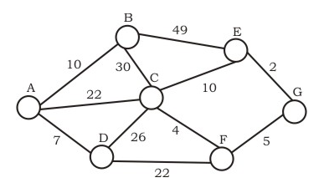

Q.7 Consider a job scheduling problem with 4 jobs J1, J2, J3, J4 and with corresponding deadlines: ( d1, d2, d3, d4) = (4, 2, 4, 2). Which of the following is not a feasible schedule without violating any job schedule?

1. J2, J4, J1, J3
2. J4, J1, J2, J3
3. J4, J2, J1, J3
4. J4, J2, J3, J1

Q.8 Consider the string abbccddeee. Each letter in the string must be assigned a binary code satisfying the following properties:

* For any two letters, the code assigned to one letter must not be a prefix of the code assigned to the other letter.
* For any two letters of the same frequency, the letter which occurs earlier in the dictionary order is assigned a code whose length is at most the length of the code assigned to the other letter.

Among the set of all binary code assignments which satisfy the above two properties, what is the minimum length of the encoded string?

1. 21
2. 23
3. 25
4. 30